### **Networked Computers Design**

1. **Network Requirements**

In order to accommodate the requirements of the network, and be able to handle heavy workloads, a client/server LAN will be designed. From the analysis it has been determined that the Petshop requires the following devices to be connected to the newly made LAN network:

|  |  |  |  |
| --- | --- | --- | --- |
| No | Equipment | Amount | Explanation |
| 1 | Cash Registers / POS registers | 3 |  |
| 2 | Receipt Printers | 3 | Requires connection to the cash register |
| 3 | Self-Scan Price Scanner | 1 |  |
| 4 | Personal Computers | 2 |  |
| 5 | Wireless Modem | 1 |  |
| 6 | Card Reader | 1 |  |

1. **Network Topology Map**

Network topology mapping is very useful, especially in monitoring large networks. It gives an entire layout of network devices and how it is connected. Not only it keeps the network admin updated, but it also supports by ascertaining the impact caused by an issue on the organization’s network. Based on the needs and requirements of the company, an extended star style topology is more fitting compared to its alternatives due to its high performance and ease of expansion and scalability (Bhardwaj). As such, the following topology map is expected to be ideal for the computer network being constructed.

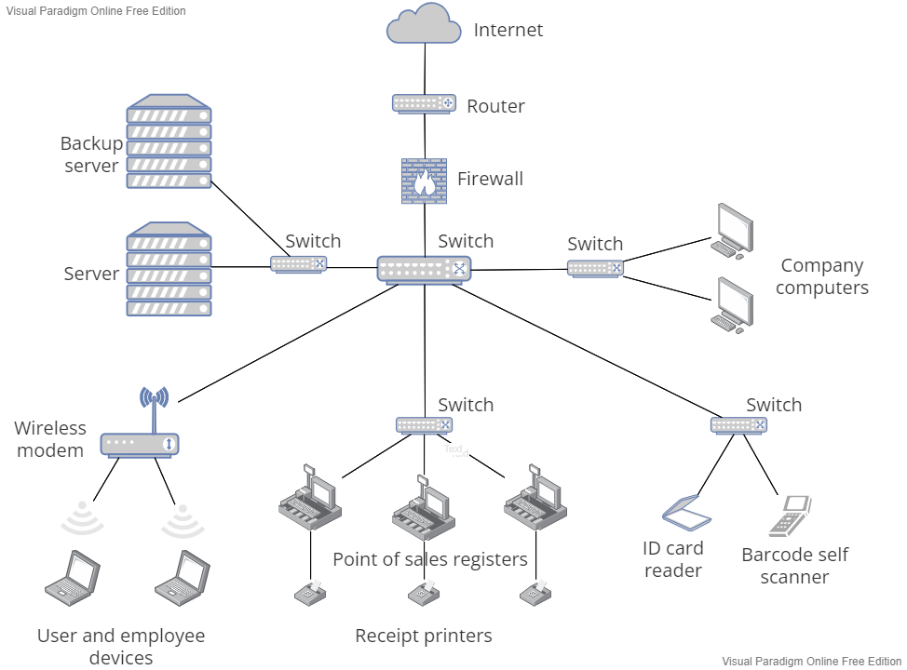

*Figure 1. Network topology*

In this network topology there is a central switch where all other devices are connected to. It is connected to a firewall, a wireless modem, and four switches, each connected to a certain group of similar devices. In addition, there is also a hierarchy in the layout. In the center all core systems, including the server and company computers are located. Other devices, where employees and customers may have access to, are found in the lower layers. In the event that some cables or unforeseen circumstances were to occur to a device or cable found on the lower layers, which are more prone to happen due to their higher use frequency, the computer network will still be able to operate normally.

1. **IP addressing structure**

An IP address is a unique address that identifies a device on the internet. It is a string of numbers separated by periods. It is typically written in decimal digits, formatted as four 8-bits fields separated by periods. Each 8-bit field represents a byte of the IP address. This form of representing bytes of an IP address is often referred to as the dotted-decimal format.

The IP addresses are classified into two parts, which is the network part and the host part. The network part specifies the unique number assigned to the network. It also identifies the class of network assigned. while , the host part is part of the IP address that is assigned to each host. It uniquely identifies the machine to the network.

As the size of the network and the rate of growth of devices in the network will not be too big, Static IP Addressing of 12 numbers address (xxx.xxx.xxx.xxx) is used to assign each device in the network.

1. **Additional Hardware and Software Requirements**

In addition to the hardware devices already owned by the company, additional hardware is required for the network to work. These hardware devices are a server, a back-up server, 4 switches, a router, and the necessary cables. Besides that, some additional software is also needed for the network to work.

The software devices that are needed are the network operating system and protocol suite. The Network Operating System planned to be installed on the Servers is Microsoft Windows Servers. This OS has long term support from Microsoft and is more beginner friendly to use, given that it provides a GUI for the server operators to more easily access all of the server’s features. In addition, the software provides extensive documentation, allowing operators to identify and deal with bugs and other issues (Tucakov, 2021).

Protocol Suite in this network is TCP/IP, this set of protocols is used in most of network today, and it contains Internet Protocol that responsible for IP Addressing, host-to-host communications, packet formatting, and fragmentation (Oracle, 2011)

1. **Network Security**

In order to maintain the security of the newly built network, the strong security measures need to be put in place during the planning and design phase in order to minimize the possibility of an unauthorized third-party accessing the network. In order to do so, a firewall is to be implemented in the LAN. Firewall is a device or software that links Wide Area Network (WAN) and Local Area Network (LAN) that prevents outside users from accessing the network. Firewall works by acting like a filter that forces communication between local network and outside network (Dandamudi & Eltaeib, 2015)



*Figure 2. Firewall*

A Back-up and Recovery system using Incremental back-up is necessary to be applied to the network. Through creating duplicates of the data which is saved on a back-up server in the network in a regular and automated manner, the possible damage to the network system can be reduced drastically. Incremental back-up only uploads files that have been updated since the previous backup. This method doesn’t require us to back-up the whole database if a certain file is updated (IBM,2022). Below is the position of the back-up server in the network.



*Figure 3. Backup Serve*r

**References**

[1]A. Networks and S. Petryschuk, "Network Design and Best Practices", Auvik Networks Inc., 2022. [Online]. Available: https://www.auvik.com/franklyit/blog/network-design-best-practices/. [Accessed: 08- Sep- 2022]

[2] ENISA, “Secure Backups”, European Union Agency for Cybersecurity, <https://www.enisa.europa.eu/securesme/cyber-tips/strengthen-technical-measures/secure-backups> [Accessed 08 Sept 2022]

[3] R. Bhardwaj, "Extended Star Network Topology » Network Interview", Network Interview, 2022. [Online]. Available: https://networkinterview.com/extended-star-network-topology/. [Accessed: 08- Sep- 2022]

[4] Sandeep Subbaiyan,“ Uncover the Benefits of Topology in Network Monitoring”. Available: <https://thwack.solarwinds.com/resources/b/geek-speak/posts/uncover-the-benefits-of-network-topolofgy-in-network-monitoring> [Accessed: 08 Sept 2022]

[5] S. Dandamudi and T. Eltaeib, “Firewalls Implementation in Computer Networks and Their Role in Network Security”, Journal of Multidisciplinary Engineering Science and Technology (JMEST), vol. 2 issue 3, March 2015.

[6] IBM Documentation, “Incremental Backups and Recovery”, IBM, <https://www.ibm.com/docs/en/db2/11.5?topic=recover-incremental-backup-recovery> [Accessed 8 Sept 2022]

[7] D. Tucakov, "Linux vs. Microsoft Windows Servers, The Ultimate Showdown", phoenixNAP Blog, 2022. [Online]. Available: https://phoenixnap.com/blog/linux-vs-microsoft-windows-servers. [Accessed: 08- Sep- 2022]

[8] Oracle, “Introducing to TCP/IP Protocol Suite”, <https://docs.oracle.com/cd/E18752_01/html/816-4554/ipov-6.html> [Accessed 8 Sept 2022]